First Aid Classes

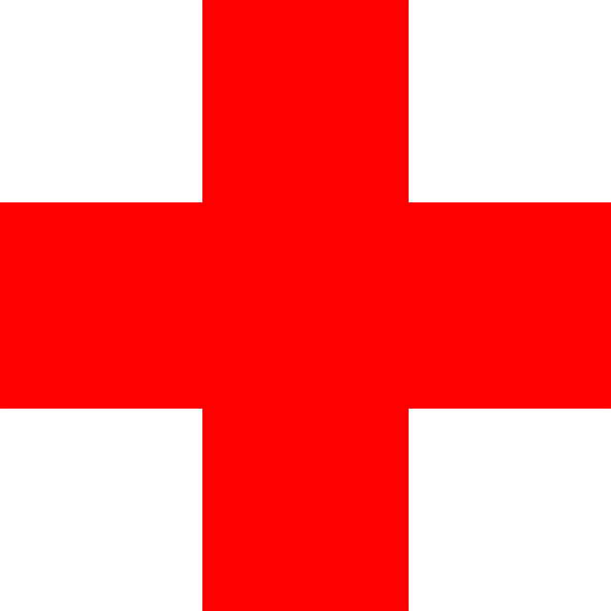

Where: Wellington Hall, St. Mary’s Rd

When: Friday 29th January (6 Weeks)

Time: 9:15- 11:15

Contact: Áine (087)1706488 to book your place!